

To Whom It May Concern:

I trust this message finds you well.

In our ongoing commitment to enhancing Global Food Solution's food safety system, we are currently conducting a comprehensive review of our approved supplier list. As part of this process, we kindly request your collaboration in providing the following information:

- Certificate of Insurance (COI)
- Third-party Audit Certificate
- Third-party Audit Report (with score)
- Product Specifications
- Allergen Declaration
- Dietary Claim Certificates
- Facility HACCP Plan
- Buy American Letter (If Applicable)
- Letter of Guarantee
- Signed GFS Food Safety Agreement

Your prompt attention to this matter is greatly appreciated, as it will significantly contribute to the accuracy and completeness of our records. This reassessment ensures that our partnership remains aligned with the highest standards of quality and safety. By supplying the required documentation, you are agreeing to abide by the terms in agreement.

Please submit the requested documents at your earliest convenience. If you have any questions or concerns, feel free to reach out to me with the contact provided below.

We value your continued partnership and cooperation in maintaining the highest standards of food safety. Thank you for your prompt attention to this request.

Best regards,
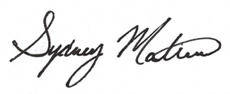
Sydney Matias
Director of Food Safety
Global Food Solutions
50 C. Constance Court
Hauppauge, N.Y. 11788
Tel (631) 428-3732
Smatias@globalfoodsolutions.CO

